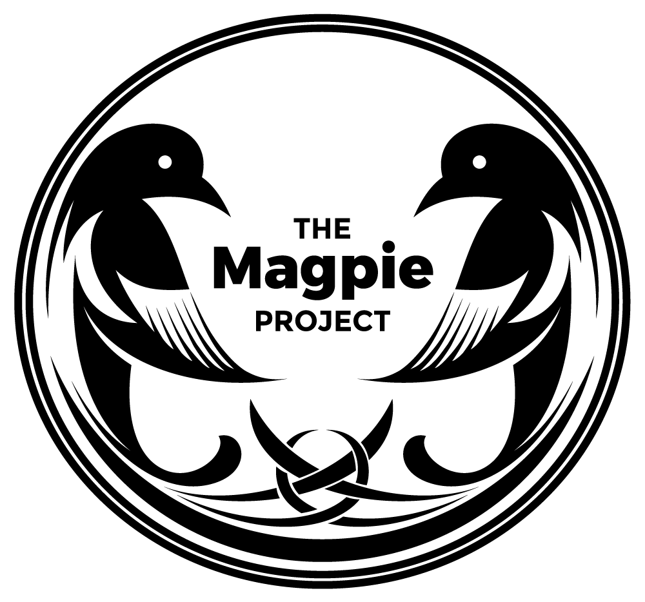
Supporting under-fives in temporary accommodation in Newham. Registered Charity Number 1176267. The Magpie Project.
www.themagpieproject.org . facebook, twitter, instagram: @magpieprojectUK

Tuesday afternoon form filling volunteer
Hours: 1 til 3pm Tuesdays (termtime only)
Start: First week in September.

Role:
To sit with our mothers and fill in online and paper forms including those for:
- Universal Credit application,
- Housing application,
- School application
- Other public services
- Face to face appointment with mums who need support with their applications

To help mothers read and understand official letters including:
- Utility bills,
- Legal letters,
- Bank letters,
- Letters from GP etc.

Computers and phones will be provided.
You are:
- Organised, Calm,
- Confident, can-do,
- Willing to work within a trauma-informed practice,
- Non-judgemental, Friendly, Approachable,
- Able to maintain boundaries,
- Able to withstand the frustrations of official forms and websites,
- Forgiving of mothers in crisis who may not bring all the correct information at hand when they arrive.
- Able to work within existing safeguarding, health and safety, and equality policies.
- Willing to undergo termly training and support and supervision.
Your skills and qualities will include:
- Empathy and communication
- Good level computer literacy with a high functional level of English.
- Ability to help fill in forms online,
- Attention to detail,
- Experience in an advice role welcomed.
- DBS or willing to undergo one.
- Ability to spot and escalate any underlying issues that would need attention.
- Community languages (especially Arabic and Albanian) very welcome.
You will:
- Engage with mums to build rapport and trust
- Empower mums to complete sections on forms which they are able to complete themselves
- Ensure mum is happy with next steps/ process where to submit/send form to.
- Support mum with uploading/scanning documents
- Identify areas for further support
Training will be given on:
- Safeguarding,
- Trauma informed practice,
- Boundaries,
- Advice services – form filling.
- GDPR
Commitment
- We ask for a minimum six month commitment to half a day - Tuesday afternoons from 1 till 3pm at our place of work (Forest Gate). From …Sept onwards
- Agree to undergo training once a term and supervision and support on an ongoing basis.
- Willing to communicate openly with all other volunteers and staff.
- Willingness to use initiative yet escalate concerns if needed.
Rewards
- Lunch, refreshments and £3 travel a day provided.
- Volunteering within a small team, friendly, open and fun, which is making a massive difference to marginalised families.
- Experience, training, professional growth, potental references for future employment.
- Being part of true change that will be visible to you from the first few weeks.
TO APPLY contact:
Marcia.Thompson@themagpieproject.org for more information or an application form.
We will need volunteers from the second week in September, Training will be the first week of September.

